P2M Operations Automation

System Analysis Document.

Created by: Abdallah Elhaj

Revision by:

Date of create: 12/3/2018

Date of revision:

Version: 1.4

Contents

1. Members Sheet Update 3

Mechanism: 3

DB considerations: 3

Mechanism of updating metadata: 3

Frequency: Monthly 4

Layout 6

2-Daily orders status: 6

Mechanism: 7

Frequency: Daily 8

Layout 9

3-Clients Invoices 10

Mechanism 10

Frequency: monthly 11

DB considerations 11

Layout 11

4- Gift Cards Report 12

Mechanism 13

Frequency: monthly 13

DB considerations 13

Layout 13

5-Oman Float 15

Mechanism 15

Frequency: Daily 16

Layout 16

6 - Points Value & Currencies 17

Notes 18

# Members Sheet Update

## Mechanism:

1. Every customer have a link that will redirect to a folder, they should upload a sheet that contain updated data of employees to that folder (every customer have his own folder).
2. The provided file mentioned above to be uploaded to this system through FTP ( File Transfer Protocol).
3. If there is an issue with customer link (that they upload on it) they should send us that sheet then it will upload from our side to upload it.
4. The data will be automatically processed where:
   * 1. New data will be added
     2. Existing data with no change will be kept as is
     3. Updated data will be automatically updated
     4. Deleted member will update a flag to indicate deletion
5. A CSV file with the updates will be exported from the system and then uploaded to P2M (by uploading it to P2M through FTP).
6. There should be a filter to choose program (Company) before exporting the CSV mentioned in point 4 if needed.
7. If customer don’t send that sheet every month system will notify the admin customer didn’t send that sheet (after 5 days).
8. If the process completed successfully the system will create a copy in another folder.
9. New employee will have empty “Pin_ID”, so after import it on (P2M system) it’ll generate a new “PIN” for them, then we need to export a CSV file after process completed to get “Pin_ID” for new employees to add that “PINs” in DB.
10. Admin will get a notification even process complete successfully or fail, if it fail admin will get the reason.

## DB considerations:

1. Company ID should be added to the Employee table as foreign key to reduce redundant data.
2. User super key (Employee ID+Comp_ID) to avoid any conflict in data.
3. Department ID should to use in employee table to refer to department that employee work in, if we any company have issue with unique departments ID then we will use the department name instead of ID.

## Mechanism of updating metadata:

1. Should to have standard Metadata to reduce number of column.
2. Old metadata will upload in another fields (new standards fields) with different values of data.

## Frequency: Monthly

* In this operation input should be from client’s side as a monthly member report
* **Required inputs** in this operation will be as below (required fields):
  1. Employee Number
  2. First Name
  3. Last Name
  4. Email
  5. Job Title
  6. Hire Date
  7. Birth Date
  8. Country
  9. Mobile Number
  10. Employee Type (Full time or Part time)
  11. Department Name or ID if it unique
  12. Address
* **Outputs** of this operation will be as below:
  1. Pin
  2. Employee Number
  3. First Name
  4. Last Name
  5. Email
  6. Job Title
  7. Hire Date
  8. Birth Date
  9. Address
  10. City
  11. Province/State
  12. Country
  13. Postal Code
  14. Telephone Area Code
  15. Mobile Number
  16. Telephone Country Code
  17. Language Code
  18. Access Groups
  19. Employee Type
  20. Deletion Date
  21. Password
  22. Disable Login
  23. Disable Earn
  24. Username
  25. FnameAR
  26. LnameAR
  27. Position Ar
  28. MNE
  29. MNA
  30. META
  31. Child
  32. MrgDate
* There is no standard for metadata, so we need to add meta data for all companies.

## Layout

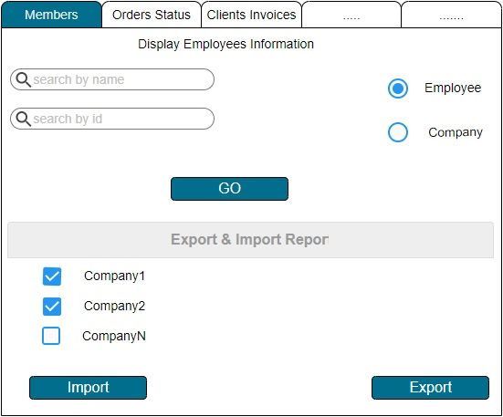

1. Search fields: it’ll be on id or name that’s use to find an employee information or company employees it’ll display the details of them, it will open new web page that’s contain all out mentioned above.
2. Import: this in case importing by FTP link not work it’ll be by clicking on button that will open a new tab to upload the updated CSV from client (it’ll redirect to FTP folder to upload new report).
3. Export: it should to choose a company before click to download a CSV from DB.

* For both import and export the user must select 1 company at least.

# 2-Daily orders status:

The purpose of this operation is to check orders status which could be.

* new
* po_received
* po_sent
* shipped
* sup_willship
* return_confimed
* Cancelled
* Delayed(to be flagged)
* Replaced (should to specify the reason as below):
  + Unavailable
  + Customer changed their mind

## Mechanism:

1. Exporting tow CSV reports from both (Partner & Supplier).

* Access needed to get a daily report as a CSV file that’s contain all orders with all the details including (Employee name, order ID, quantity, status, order date.. etc)

1. Import the exported file to our automation system through FTP
2. After that data will be processed as below
   1. Date of orders will calculate as (current date – order creation date) if interval more than 32 days flag will raise (Delayed order).
      1. Supplier 🡪 Po_recieved = 5 (work days)
      2. Po_recieved🡪 supwillship =10 (work days)
      3. Supwillship 🡪 Shipped =10 (work days)
   2. For each stage if half of duration exceeded it’ll raise a flag and send email to the admin, if total duration exceeded it’ll change to be red and raise urgent to admin to contact the supplier.
   3. New order will be inserted to our database with status “new”.
   4. If orders status change from “po_sent, sup_willship” to “shipped” (Redemptions) or “po_received” (GRS) it will create a copy to below tables
      1. Shipped 🡪Clients Invoice table.
      2. Po_received 🡪 Gift Cards Invoice table.
   5. If status changed to “Cancelled” it’ll change cancelled flag to be yes and allow admin to add reason of cancellation.
   6. If status “return_confirmed” it’s cost must be subtracted, so before moving it to another table it’ll be multiplied by (-1), there is a column in DB called Reason of Return it will use to know why customer returned it.
   7. (new ,po_sent ,sup_willship ,return_confimed)items will be shown in separate screen.
   8. If the customer want to replace him there is a column to add reason about replacing as drop down menu as below:
      1. Unavailable
      2. Customer changed his mind
   9. There a field to show when last change of order stauts.

## Frequency: Daily

* Mandatory inputs for this operation as below
  + For Redemption report:
    - P2M Order Number
    - PIN
    - Employee ID
    - First Name
    - Last Name
    - PIN Employee ID
    - Job Title
    - Phone Number
    - Catalog Name
    - Reward Name
    - Quantity
    - Order Status
    - Current Status
    - Discount Coupon
    - Redemption Amount
    - Discount Applied
    - Member Paid Point
    - Date and Time
  + Gift cards report required fields:
    - GRS Order #
    - Partner System Order #
    - User Id
    - First Name
    - Last Name
    - Order Date
    - Company Name
    - Phone Number
    - Item Number
    - Item Description
    - Item Option
    - Quantity
    - Email
    - Product Cost
    - Catalog Code
    - Date Processed
    - Status
    - Quantity Shipped
    - Tracking Number
    - Courier Name
* In this operation, there is no output it’s just processing the data.

## Layout

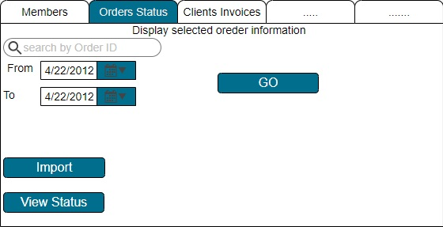

* Search query will be on order id or status.
* It’s optional to do it between tow dates.
* Import button to add new reports mentioned above.
* After choosing any type of search, should clock on GO button that’s will appear a new tab that’s contain search result as below picture.

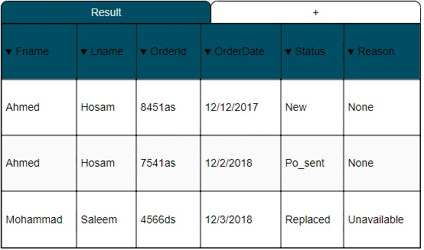

* Reason drop down menu will be as below:

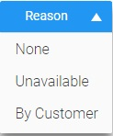

* By clicking on view Status that will appear a new screen that’s contain orders information as below and every field are editable.

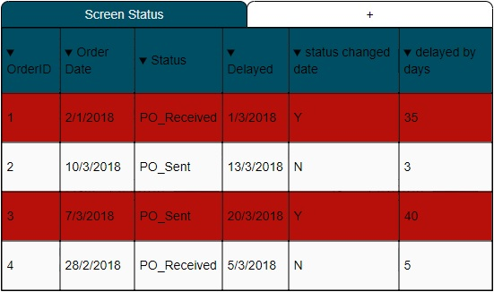

* Input sample for partner and supplier it’s as below:

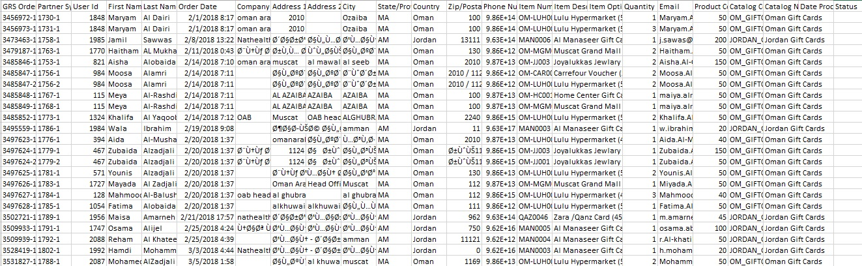

Supplier Report Sample.

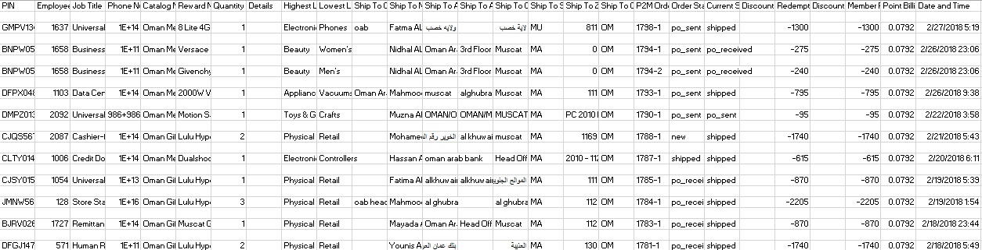

Partner Report Sample.

# 3-Clients Invoices

This operation is to generate monthly invoices for clients’ redemptions.

## Mechanism

* In this operation there is no inputs, it will come from daily order status operation, but it need some processing as:
  + Every order (shipped) should multiply it by the quantity and adding shipping fees
  + Total (sum of) redemptions to be calculated
    - # of points
    - Currency equivalent to the client’s
    - Then converted to USD
* Convert total to USD then store it in "Cost in USD", or to local currency if cost in points by below equations (number below as example):
  + - OMR*2.61=USD
    - JOD/0.709=USD
    - Pt’s*0.07519=JOD
    - Pt’s/12.625=OMR
* The generated report should be downloadable (excel) from “Clients Invoice” table it’s the same of our template.
* Every item will print in that report it status will be shipped.

## Frequency: monthly

## DB considerations

There is a relation between this table and currency table (currency_id) will be a foreign key; this needed to change currency ratio if it changed.

## Layout

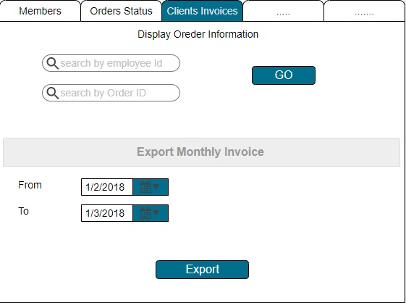

* Before clicking on export user must specify dates.
* Layout of report should be like currently template as below:

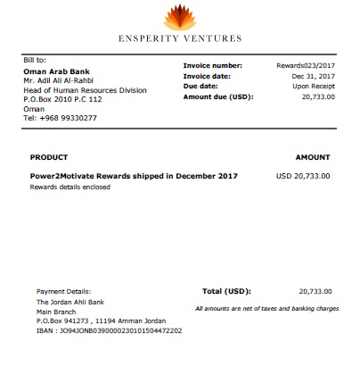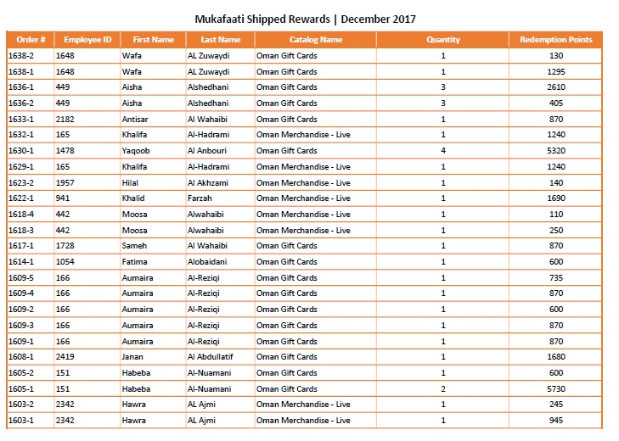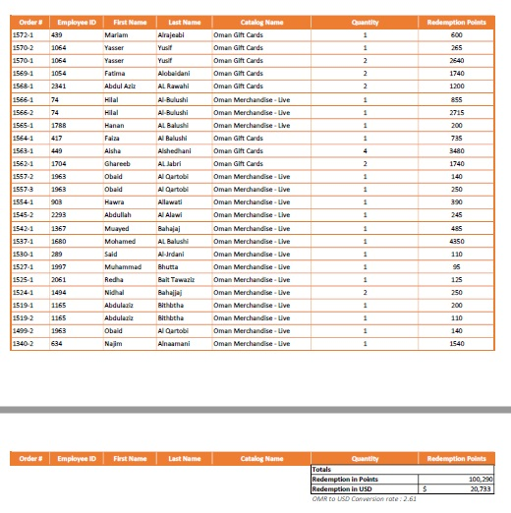

* Go button will open new tab that contain order information as below layout:

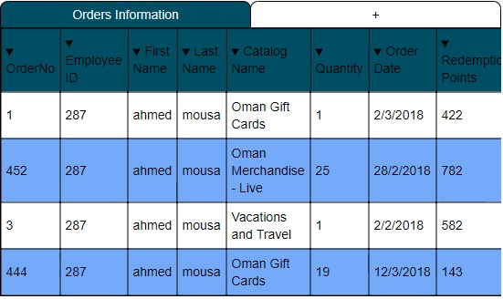

* Export button to export monthly invoice (add fields of output) output will be as below:
  1. OrderNo
  2. Employee ID
  3. First Name
  4. Last Name
  5. Catalog Name
  6. Quantity
  7. Order Date
  8. Redemption Points
  9. Total Redemption in Points
  10. Total in USD

# 4- Gift Cards Report

This operation is to generate a monthly invoice of ordered Gift Cards

## Mechanism

* In this operation there is no inputs, it will come from daily order status operation, but it need some processing as:
  + Every order should multiply it by the quantity and adding shipping, service and handling fees (there a table of handling fees).
* Convert cost to USD then store it in "Cost in USD", or to local currency if cost in points by below equations:
  + - OMR*2.61=USD
    - JOD/0.709=USD
    - Pt’s*0.07519=JOD
    - Pt’s/12.625=OMR
* Calculate the total local cost
* Convert total cost to USD
* Monthly it's should to do below:
  + Generate a report (excel)
  + Move all orders to another table that contains old shipped orders from “Carlton Invoice”

## Frequency: monthly

## DB considerations

There is a relation between this table and currency table (currency_id) will be a foreign key; this needed to change currency ratio if it changed.

## Layout

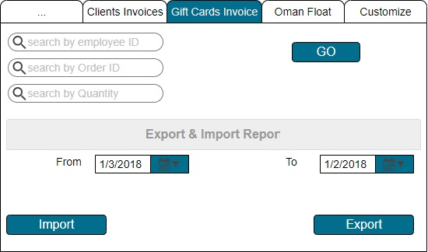

* Export button to export monthly invoice output will be as below:
  1. Order Id
  2. Line Number
  3. Reward Name
  4. Order Date
  5. Total Cost
  6. Local Cost
  7. Cost in USD
* Go button will open new tab that contain order information as below layout:

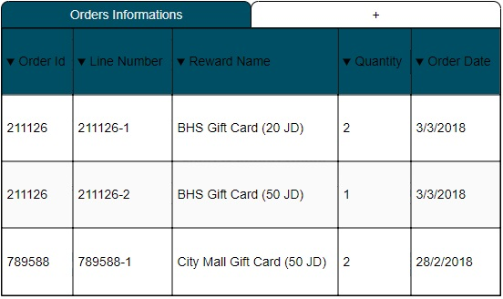

* + If there is an order that’s more than 5 it’ll appear in different color.
  + Template of invoice will be as below:

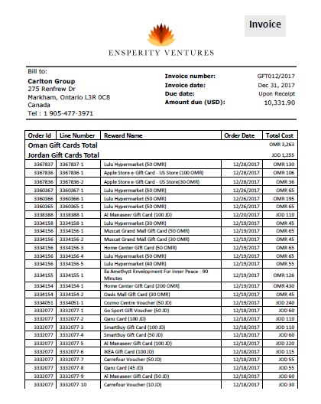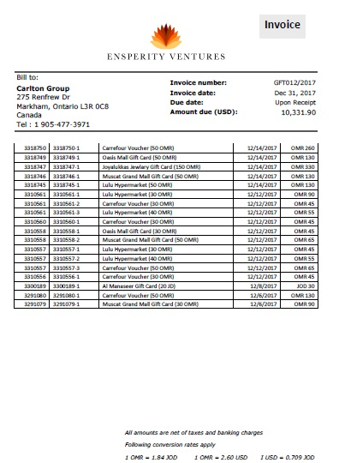

# 5-Oman Float

The purpose of this operation to check daily how many gift cards the courier delivered and how much remaining float he has.

## Mechanism

* The courier should send a daily report to provide orders status (delivered, canceled, pending)
* Daily remaining float to be indicated
* Any amount transferred to courier must be entered by admin (added to the float by enter new value then click on add)
* Input of this operation will be like output as below:
  1. ID (for our and the Supplier reference)
  2. Date
  3. Order No (same of P2M ID or number)
  4. Member Name
  5. Gift Card name
  6. Gift Card cost
  7. Quantity
  8. Total cost (cost x quantity)
  9. Delivery fees (considered once for 1 destination even with multiple items)
  10. Total Cost with Delivery
  11. Status
  12. Delivery Date
  13. Payments to Oman
  14. Date of payment
  15. Remaining float

## Frequency: Daily

## Layout

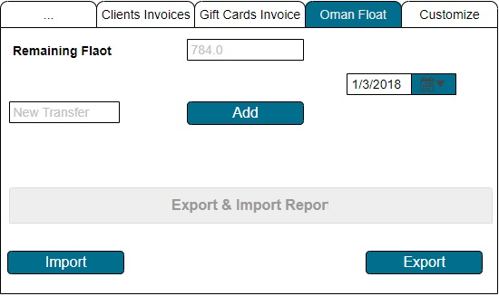

* Remaining float to show how much the courier have (every order database will do calculation in back-end).
* New transfer to add how much money we send to him.
  + Database will save the date of transfer automatically
* Import to insert excel sheet from courier and get an updated status on the system
* Web view table and then ability to export the output report and send to courier to reconcile
* Date of adding must be set before clicking on add.
* Template of report as below:

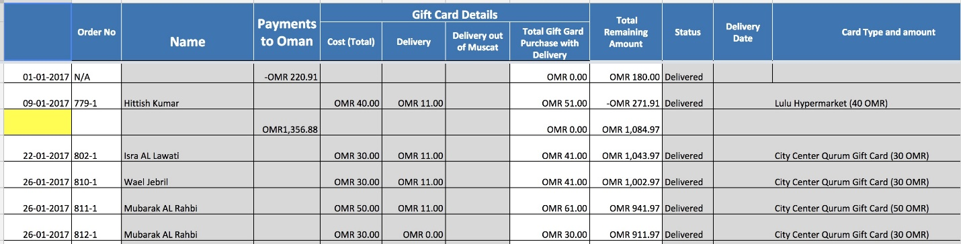

# 6 - Points Value & Currencies

The purpose of this table to define new points value per client, and update currencies & rates.

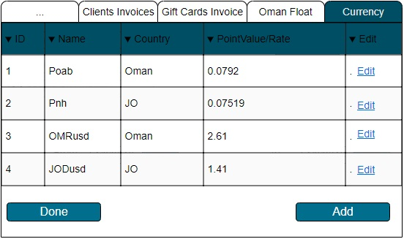

* Add button will add all attributes (ID,Name,Country,PointValue/Rate).

# Notes

* For each operation outputs depends on table fields, it’ll be a combination of fields that we’ll choose.
* It’s should to have currency table that’s contain the rate of currency to make it dynamic.
* Handling fees, shipping fees, and service will add to a standalone table.
* Access privileges:

There will be a username and password this will allow people who just have the credential.

Please tell me any if you have another idea about privileges.

* Backup process:

It’ll be daily for database on second server.

* Cleansing process:

It’ll be button in web page to choose which table need to clean as below layout:

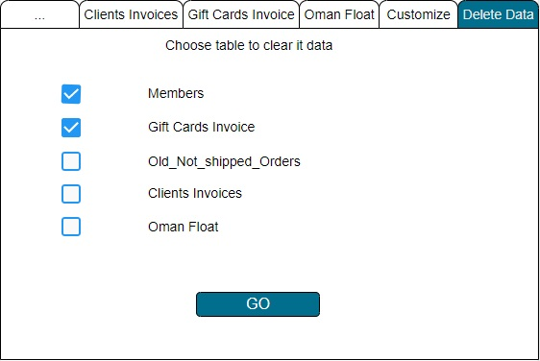

* I need (2-3) to learn new language to build a web-application, I’ll start with ASP.Net many guys recommended me to learn it because it’s easier, after that I’ll put the estimation time for each task.